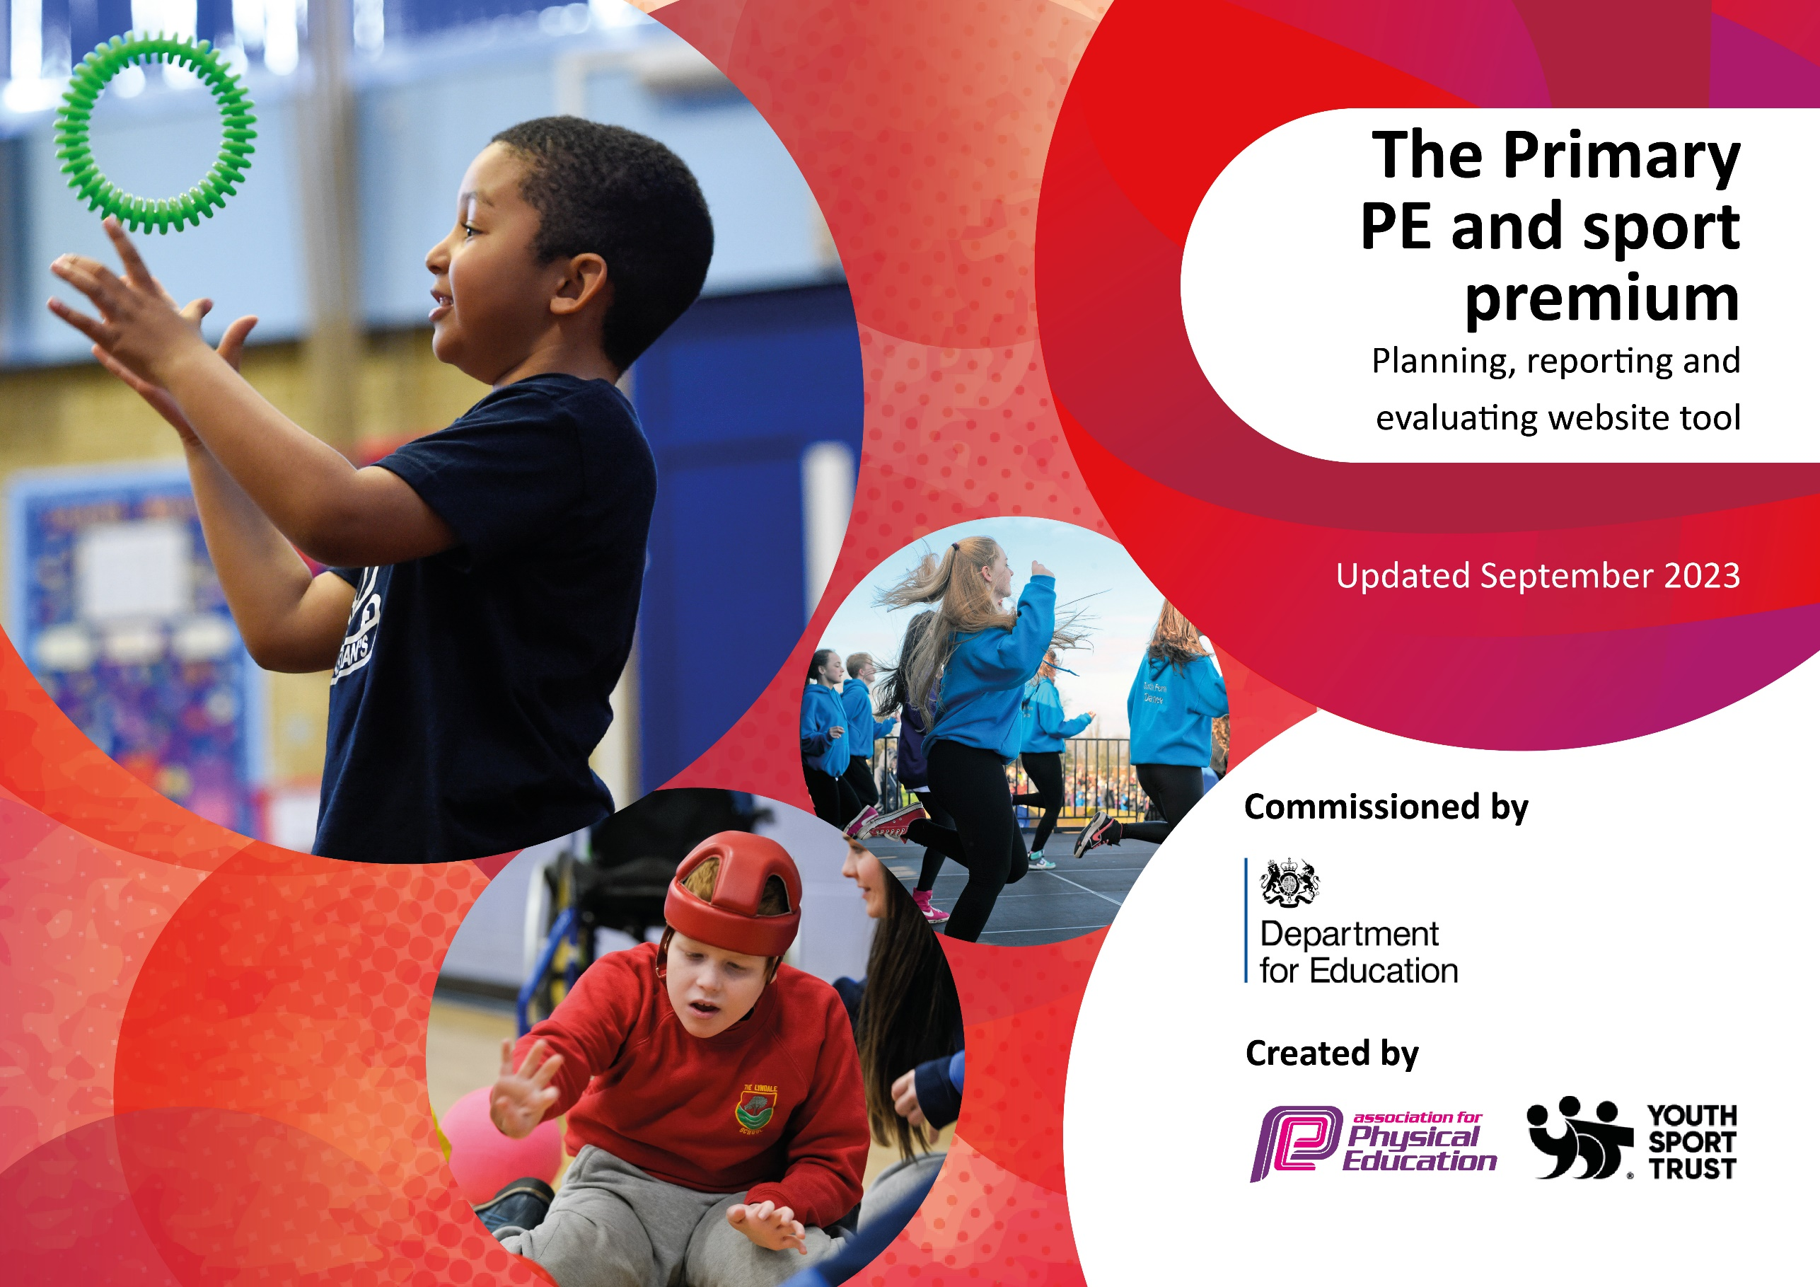

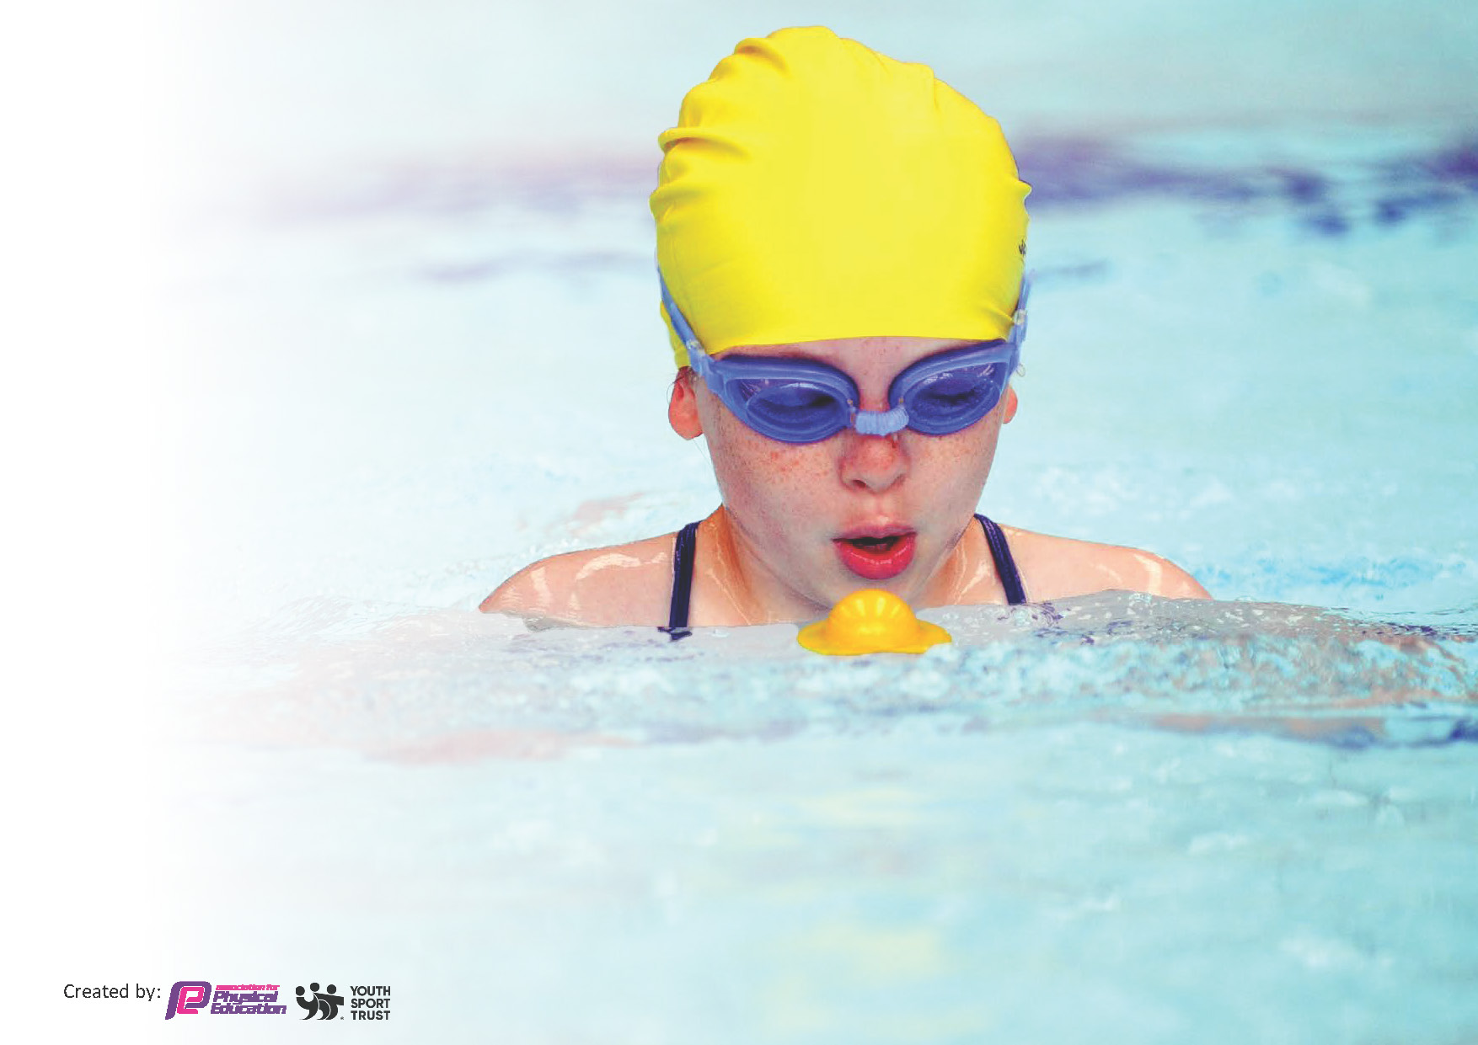
This template can be used for multiple purposes:
by:
- It enables schools to effectively plan their use of the Primary PE and sport premium
- It helps schools to meet the requirements (as set out in guidance) to publish information on their Primary PE and sport premium
- It will be an effective document to support Ofsted inspections enabling schools to evidence progress in Physical Education (PE) and evidence swimming attainment, which forms part of the PE National Curriculum. We would recommend schools consider
the Intent, Implementation and Impact of any spend, as examined within the Education Inspection Framework.

It is important that your grant is used effectively and based on school need.

Schools must use the funding to make additional and sustainable
improvements to the quality of the PE, School Sport and Physical Activity (PESSPA)
they offer. This means that you should use the Primary PE and sport premium to:

- Build capacity and capability within the school to ensure that improvements made now will benefit pupils joining the school in future years
- Develop or add to the PESSPA activities that your school already offers.

The Primary PE and sport premium should not be used to fund capital spend projects; the school’s core budget should fund these. Further detail on capital expenditure can be found in the updated Primary PE and sport premium guidance.

The Primary PE and sport premium guidance, outlines 5 key priorities that funding should be used towards. It is not

necessary that spending has to meet all the key priorities, you should select the priorities that you aim to use any funding towards.

Although completing this template is not a requirement for schools, schools are required to publish details of how they spend this funding. Schools must also outline what the impact this funding has had on pupils’ PE and sport participation and attainment and how any spending will be sustainable in the future. All funding must be spent by 31st July 2024.

The Department for Education has worked closely with the Association for Physical Education (afPE) and the Youth Sport Trust (YST) to develop this template and encourages schools to use it. This template is an effective way of meeting the reporting requirements of the Primary PE and sport premium.
Review of last year’s spend and key achievements (2022/2023)

We recommend you start by reflecting on the impact of current provision and reviewing your previous spend.

Activity/Action | Impact | Comments
To increase engagement in and enjoyment of physical activity to promote active, healthy lifestyles.  To participate in inter-schools competitions by engaging with Halton School Games | We introduced the Walk to School initiative, data shows that the number of children who walk to school improved.  More children participated in competitions, pupil voice shown that the children enjoyed each opportunity that we provided. The children took great pride representing our school and we observed more children were engaged in PE lessons and our sports after school numbers improved. | We are looking forward to rolling this out fully in September 2023 to improve and engage more children further.  We were delighted to receive the Bronze award through Halton School Games.

Key priorities and Planning
This planning template will allow schools to accurately plan their spending.

Action – what are you planning to do | Who does this action impact? | Key indicator to meet | Impacts and how sustainability will be achieved? | Cost linked to the action
To increase engagement in and enjoyment of physical activity to promote active, healthy lifestyles. | All pupils because they will be taking part.  All staff members – to show enthusiasm to promote and teach physical activity.  Staff members to use Twitter to publish evidence of work they are doing in PE and during lunch and play times to promote physical activity, using the @halebank_sch. | Key indicator 2- Engagement of all pupils in regular physical activity.  The UK Chief Medical Officers recommend that all children and young people should take part in moderate to vigorous intensity physical activity for at least 60 minutes every day. Children with special educational needs and disabilities should take part in 20 minutes of daily activity.  Key indicator 3 – The profile of PE and Sport is raised across the school as a tool for whole school improvement. | - Daily Mile –providing children with another opportunity to meet their daily activity goal.  - Walk to School – Living Streets Tracker – Tracked each morning across the whole school and rewards given half termly.  - Evidence on Twitter and monitoring trackers.
To provide a wider variety of equipment indoor, outdoor and playtime to increase standards in PE and Sport | Each class will have their own equipment that will be colour coordinated and stored by each class in labelled crates. Children can then access their own equipment during lunch times and play times. They will have a range of equipment for both team and individual activities. | Key indicator 2 - Engagement of all pupils in regular physical activity.  Key indicator 4 – broader experience of a range of sports and activities offered to all pupils.  All children should have equal access to high-quality PE provision and opportunities to experience and participate in a wide range of sports and physical activities. | Providing children with higher standard equipment to access during play times and lunch times.  Coloured coordinated for each class to monitor and maintain.  Storage solutions to be purchased for indoor equipment to be monitored and stored safely.
To continue to improve the delivery of structured physical activity at lunchtime. Provide opportunities for sports ambassadors (KS2) and play leaders to manage and support activities and games. | Mid-day assistants – CPD – LP subject lead to arrange and deliver training.  UKS2 – 2 sports ambassadors  Teachers to work collaboratively to train and support play leaders at playtimes. | Key indicator 2- Engagement of all pupils in regular physical activity.  Key indicator 3 – The profile of PE and Sport is raised across the school as a tool for whole school improvement. | CPD opportunities using materials from GetSet4PE scheme. – Activities and training available. | GetSet4Pe Subscription £440
To increase the amount of inter and intra school competitions. | LP to track children who are participating in competitions.  LP to continue to work in conjunction with Progressive sports to plan inter school competitions.  To continue to participate competitions organised through Halton School Games. | Key indicator 2- Engagement of all pupils in regular physical activity  Key indicator 5. – Increased participation in competitive sport. | LP to monitor competitions using GetSet4Pe Tracker.  Monitor engagement through Twitter.  Individual and team achievements to be shared in Collective Worships and in the newsletter. | Progressive sports -  Halton School Games - £545  GetSet4PE - £440
To offer a wide variety of after school clubs, that promote physical activity. | All pupils have the opportunity to attend afterschool clubs.  LP to work collaboratively with Progressive sports to deliver a Girls Football club during 1 lunch time and 1 playtime each week. | Key indicator 1 – increased confidence, knowledge and skills of all staff in teaching PE and sport.  LP to gain CPD from Progressive Sports to deliver football sessions.  Key indicator 4 - broader experience of a range of sports and activities offered to all pupils.  Key indicator 5 – Increased participation in competitive sport. |  | Progressive sports - £2660  Cricket after school club. – free of charge
To continue to engage and participate with Halton School Games CPD, competitions and events including and transport. | LP to continue to book school competitions through Halton School games.  Children across most year groups to take part in competitions and events.  Teachers and/or TAs to access any CPD opportunities that become available. | Key indicator 1 – increased confidence, knowledge and skills of all staff in teaching PE and sport.  Key indicator 2- Engagement of all pupils in regular physical activity  Key indicator 3 – The profile of PE and Sport is raised across the school as a tool for whole school improvement. | To monitor event participation.  To engage with Halton’s organiser regarding upcoming events and competitions.  More children will have the opportunity to en | Halton School Games -£545  Coach/bus/taxi – intended approx cost - £400
To increase staff members’ confidence, knowledge and skills to teaching PE and sport by following and teaching using GetSet4PE Scheme and accessing CPD with Progressive Sports. | LP to introduce our new PE curriculum to staff.  All teachers to access the CPD offered on GetSet4Pe.  Teachers and TAs to gain CPD from working alongside Progressive Sports to deliver high quality PE lessons. | Key indicator 1 – increased confidence, knowledge and skills of all staff in teaching PE and sport. | All staff will have the opportunity to up level their skills by accessing CPD opportunities.  LP to observe PE lessons and gain pupil voice. | Halton School Games - £545  Progressive Sports -  £6105  GetSet4Pe - £440
To deliver top up swimming lessons for those pupils who are not meeting the expected standard. | Pupils in Y5&6 who are unable to swim 25m unaided. | Key indicator 2 -The engagement of all pupils in regular physical activity – the Chief Medical Officer guidelines recommend that all children and young people aged 5 to 18 engage in at least 60 minutes of physical activity per day, of which 30 minutes should be in school. | More pupils will be able to swim and meet national expectations at the end of KS2.

Key achievements 2023-2024
This template will be completed at the end of the academic year and will showcase the key achievements schools have made with their Primary PE and sport premium spending.

Activity/Action | Impact | Comments

Swimming Data
Meeting National Curriculum requirements for swimming and water safety.
Priority should always be given to ensuring that pupils can perform safe self-rescue even if they do not fully meet the first two requirements of the National Curriculum programme of study

Question | Stats: | Further context  Relative to local challenges
What percentage of your current Year 6 cohort can swim competently, confidently and proficiently over a distance of at least 25 metres? | % | Use this text box to give further context behind the percentage.  e.g., 30% - we are struggling to get pool space due to our local pool closing so we have had to use a much smaller local school pool. We have had to limit the number of pupils attending swimming lessons during one term which means some pupils have attended fewer swimming lessons than others.
What percentage of your current Year 6 cohort can use a range of strokes effectively [for example, front crawl, backstroke, and breaststroke]? | % | Use this text box to give further context behind the percentage.  e.g., Even though your pupils may swim in another year please report on their attainment on leaving primary school at the end of the summer term 2024

What percentage of your current Year 6 cohort are able to perform safe self-rescue in different water-based situations? | % | Use this text box to give further context behind the percentage.
If your schools swimming data is below national expectation, you can choose to use the Primary PE and sport premium to provide additional top-up sessions for those pupils that did not meet National Curriculum  requirements after the completion of core lessons. Have you done this? | Yes/No
Have you provided CPD to improve the knowledge and confidence of staff to be able to teach swimming and water safety? | Yes/No

Signed off by:

Head Teacher: | (Name)
Subject Leader or the individual responsible for the Primary PE and sport premium: | (Name and Job Title)
Governor: | (Name and Role)
Date:

