Cherry Class Reception

 | Autumn 1 | Autumn 2 | Spring 1 | Spring 2 | Summer 1 | Summer 2
Pathways2 Write | Peace at last  by Jill Murphy | The Three Little Pigs by Mara Alperin | Let’s all creep through crocodile creek by Jonny Lambert | The Pirates are Coming!  by John Condon | Gigantosaurus  by Jonny Duddle | The See Saw  by Tom Percival
 | Outcomes  Fiction: story with focus | Outcomes  Fiction- traditional tale with a character focus | Outcomes  Fiction – Journeys (retell with a map) | Outcomes  Fiction – description of a pirate ship | Outcomes  Fiction – to rewrite the story | Outcomes  Fiction – to rewrite the story

Willow Class Year 1 and Year 2
Willow | Autumn 1 | Autumn 2 | Spring 1 | Spring 2 | Summer 1 | Summer 2
Pathways2 Write | Misha Makes Friends by Tom Percival  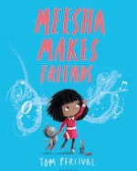 | The Owl who was Afraid of the Dark by Jill Tomlinson  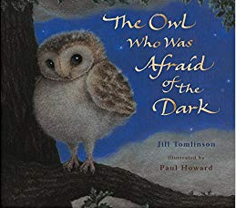 | The Dragon Machine by Helen Ward  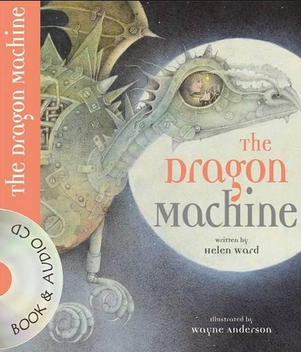 | Katie In London by James Mayhew  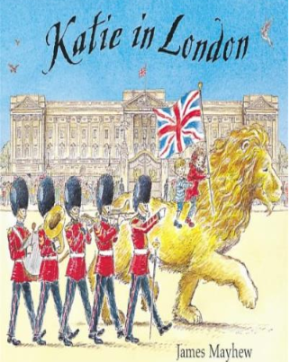 | The Last Grey Wolf by Mini Grey  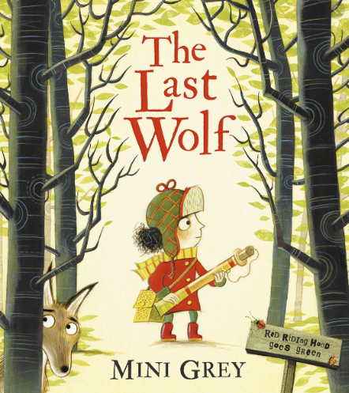 | Grandad’s Secret Giant by David Litchfield  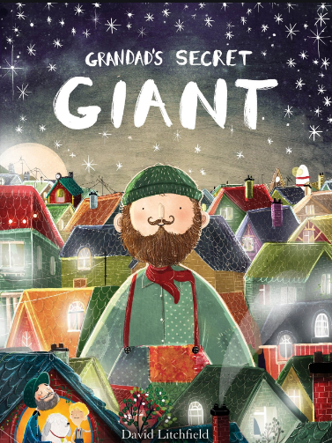
Outcome | Fiction: writing focus on characters | Non-chronological report | Fiction: adventure focus | Recount: diary entry | Letter: letter in role | Fiction: moral focus
Poetry |  | The Owl and The Pussycat by Edward Lear Nonsense poems |  |  |  | Father and I in the Woods By David McCord  Shape poems
Pathways2Read | Troll by Julia Donaldson The Three Billy Goats Gruff by Mara Alperin | Above and Below by Patricia Hegarty Information Text | The Dragonsitter by Josh Lacey  Real Dragons! by Jennifer Szymanski (National Geographic Kids series) | Owen and the Soldier by Lisa Thompson | Fantastic Mr Fox by Roald Dahl | Grimm’s Fairy tales (Usborne Books)
Focus | Fiction: fantasy Fiction: fairy tale | Information | Recount Information | Fiction: story with a familiar setting | Fiction: adventure | Fiction: fairy tale  Main

Beech | Autumn 1 | Autumn 2 | Spring 1 | Spring 2 | Summer 1 | Summer 2
Pathways2 Write | Gorilla by Anthony Browne  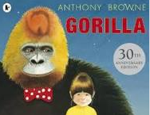 | Leon and The Place Between by Graham Baker-Smith  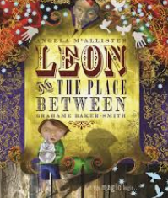 | Escape from Pompeii by Christina Balit  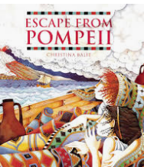 | When the Giant Stirred by Celia Godkin  Stone Age Boy  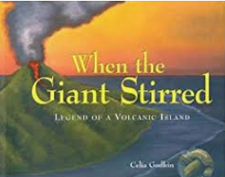 | Welcome to London  Marcos Farina  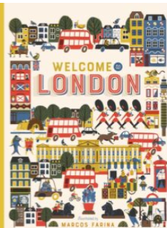  Topic unit | Blue John by Berlie Doherty  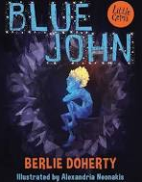
Outcome | Fiction: fantasy story | Recount: diary | Fiction: historical narrative | Fiction: adventure story | Non-chronological report | Letters & Explanation
Poetry unit |  | British poets on Identity  B Zephaniah  J Caelho |  |  | The Lost Lost Roger McGough  List poems
Reading text | A World Full of Animal Stories: 50 Folk Tales and Legends by Angela McAllister | Stig of the Dump by Clive King | DK Findout! Volcanoes by Maria Gill | Ariki and the Island of Wonders by Nicola Davies | The Thames and Tide Club: The Secret City by Katya Balen* | Fantastically Great Women Who Saved the Planet by Kate Pankhurst  Plastic Pollution by The Literacy Company
Focus | Fiction: traditional tales | Fiction: fantasy | Information | Fiction: adventure | Recount: biography Information | Information

Beech Class Year 3 and Year 4

Oak Class Year 5 and Year 6

 | Autumn 1 | Autumn 2 | Spring 1 | Spring 2 | Summer 1 | Summer 2
Pathways2 Write | Star of Fear, Star of Hope by Joe Hoestlandt  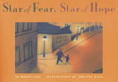 | A Place for Me by Dame Floella Benjamin  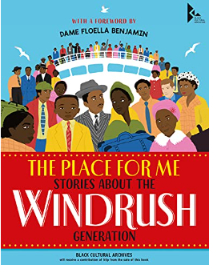 | The Selfish Giant By Oscar Wilde  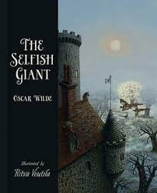 | Shackleton’s Journey by William Grill  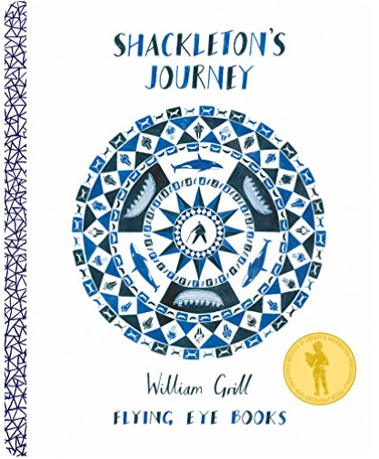 | Manfish by  Jennifer Berne  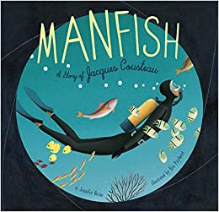 | The Paperbag Prince by Colin Thompson  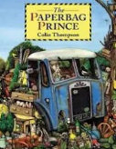
Outcome | Fiction: flashback story  Information text | Information/ explanation texts | Fiction: classic narrative | Recount: journalistic writing Diary Discussion | Recount: biography  Fiction | Persuasion Information
Poetry | Blitz by Mary Desiree  Personification |  |  |  |  | The Sun In Me  Free verse
Pathways2Read | Poems from the Second World War selected by Gaby Morgan  When we were Warriors by Emma Carroll | Jungle Book by Rudyard Kipling (Macmillan)  Martha’s Suitcase by The Literacy Company | The Happy Prince and Other Tales by Oscar Wilde | Great Adventurers by Alastair Humphreys | Exploring the Amazon by The Literacy Company  The Explorer by Katherine Rundell | Sky Chasers by Emma Carroll

